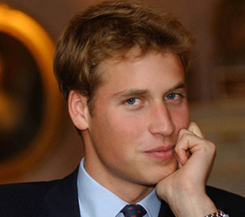
- Read the short text below. Complete the sentence at the end of the text.
His full name is William Arthur Philip Louis Windsor. He has two nicknames? Wills and Wombat. He’s very good-looking , with blond hair and blue eyes. He is tall and slim. He was born on June 21 1982 at 9.03. Не is left-handed. When he was a small boy he used to say: “I’m going to be a fireman.” His favourite drink is Cola. His favourite foods are venison (deer) and homegrown vegetables. He likes Cindy Crawford and Emma Bunton from the Spice Girls. Who is this British star& He isn’t a pop-star or an actor. He is …
- Complete the sentence using words below. What prince is going to do?
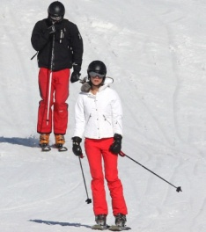
ski


play tennis

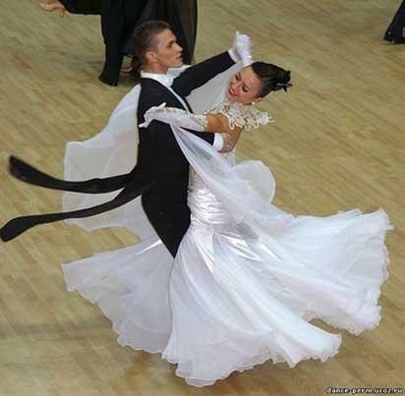
dance

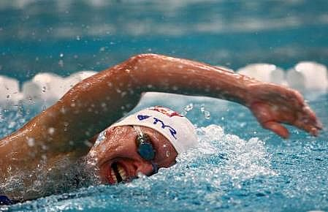
He is going to…
swim

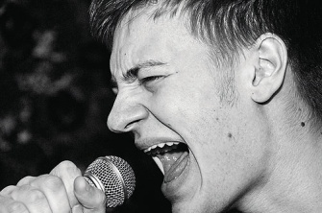
sing

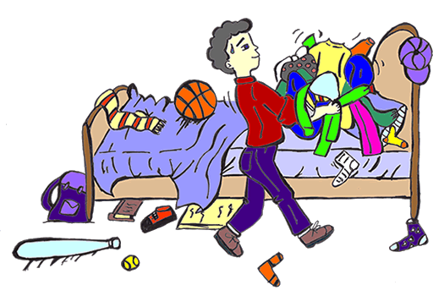
tidy his room

- Read William’s New School Year resolutions. Change them into serious ones.
During the next school year I’m going to / I’m not going to
Example: 1) I’m going to stop eating chocolate

- Eat more chocolate at the lunch break.
- Miss classes.
- Never get ready for lessons.
- Lie to my friends.
- Not to help to my Mum.
- Stop reading books.

- Translate into English next sentences.
- Я собираюсь пойти завтра в школу.
- Он собирается играть в футбол.
- Она собирается петь.
- Мы собираемся плавать.
- Я собираюсь есть чипсы.

